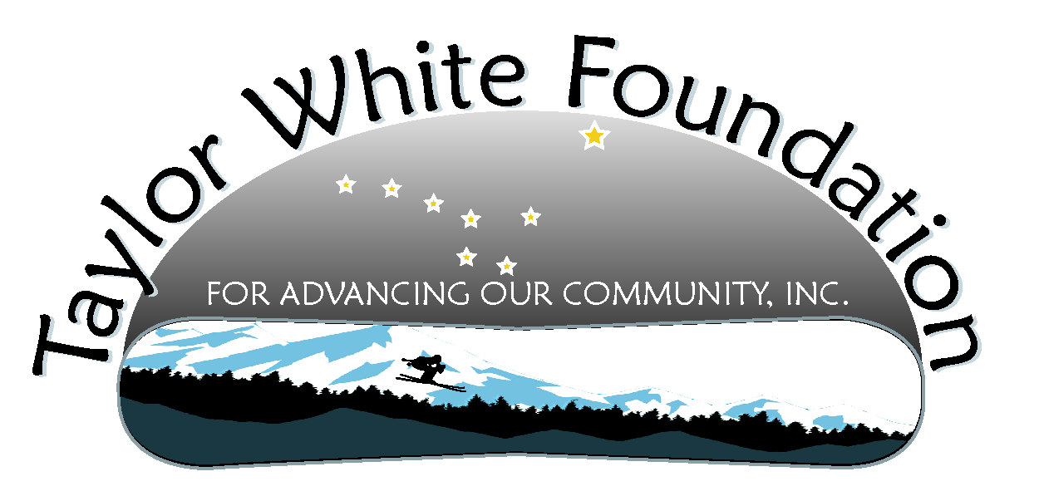
Taylor White Foundation Board Meeting
July 24, 2011

Attending: Sam, Linda, Morgan, Lauree, Carol
Item
- Roadside Memorial | Al Clough, DOT Regional Director sent the Foundation a letter asking for input on how to alert family and friends of those who had memorials by the side of the road in areas where they would be widening the road.  The board members present suggested that the Foundation will go out and “map” the current memorials from the kayak launch just past Eagle Beach to the end of the road and see if they knew who the memorials belonged to. They would give that information to DOT.  They also suggested that the Foundation could help with dismantling the current memorials and see if DOT could provide storage space for them. Once the project was completed we could put them back up.  Morgan and Sam volunteered to do the mapping prior to August 1. Carol will email or call Al to see what he thought of the suggestion.
- Car Display Update  - Housing Display  - August Schedule  - Permission to park report | The display will be at JYS August 2, at DMV from August 3-19, and at Nugget Mall for the Back to School Event August 20. We need to find drivers to deliver the trailer. Carol will put out a request in an email to the distribution list.  Morgan brought up the fact that we don’t have a page on our website dedicated to the display. He will build a page, using a picture he has on his phone, and Carol will supply the text. We will also include the schedule of where the display will be.
- Awareness  - Slide  - Back to school – ideas for working with schools | AK Grafix has the slide for the advertisement. It will begin running July 29 and will run through August 19 at Glacier Cinema on all 5 screens and will display for 15 seconds at a time.  Special thanks to Devyn Fruge (spelling ?) who helped design the slide to Ak Grafix specs, Morgan for coordinating the slide, and Tyler for the picture we ended up using. Nice job everyone.  We talked about awareness type activities in the middle school for this next year. Ideas were a writing or art contest that promote awareness, seeing if it could be part of an assembly, and maybe include prizes. Linda and Lauree will meet with Molly Box and Molly Yerkes and come back to the board with a proposal.  We decided to wait on discussing at the high school until Graham and Kristin were present
- Documentary  - Web Analytics Report  - August Schedule | We will be showing the documentary at JYS on August 2  The documentary showed a dramatic upswing after the article in the paper on July 11. The page had 111 hits and the video was viewed by 89 unique viewers.
- Simulator – Driver’s Training, how to proceed from here | Carol will do some research on granting and send examples to Sam. She will also contact Katie to see what Katie has already done.
- Next meeting | The next meeting will be August 28 from 4:30-6:00 at the White House. We would also like for people to think about a retreat from noon-5:00 PM in September to get really clear what our goals and energy will go to in the coming 12 months. A proposed date is September 18.

